YOUR DEALERSHIP NAME HERE
SOCIAL DISTANCING
KEEP YOUR DISTANCE 6 FT

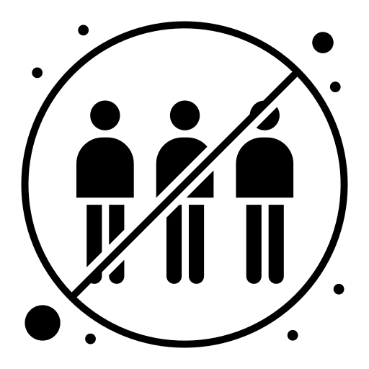
AVOID TOUCHING
AND CROWDS

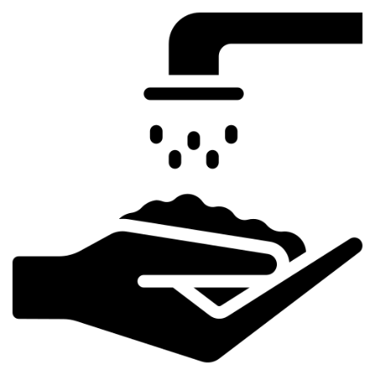
WASH YOUR HANDS FOR AT LEAST
20 SECONDS WITH SOAP WHEN
ENTERING THE BUILDING AND AFTER
USING THE RESTROOM

